**Assignment sheet for IAM**

Assignment 1 :- Create an IAM user with username of your own wish and grant administrator policy.

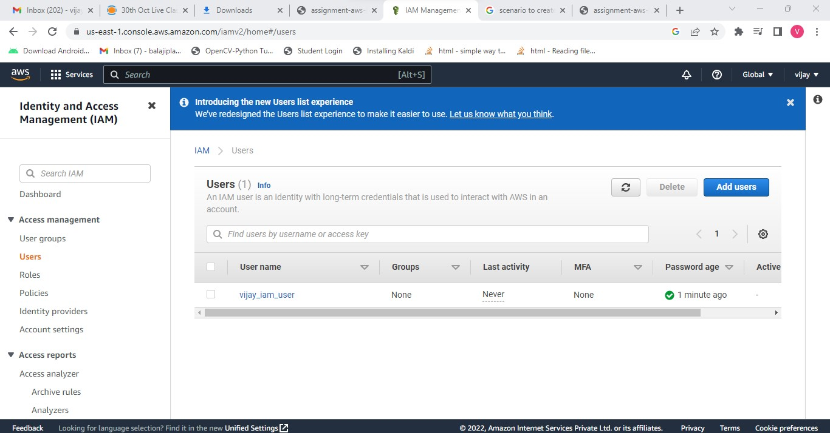

Here IAM user **vijay_iam_user** is created with administrator policy.

**Assignment 2 :- Hello students, in this assignment you need to prepare a developers team of avengers. - Create 3 IAM users of avengers and assign them in developer’s groups with IAM policy.**

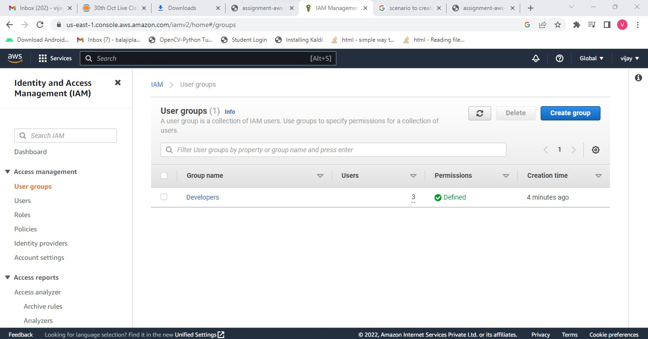

Created a **Developers** group with **3IAM** users and given all the **IAM policies** to the group.

Assignment 3 :- Define a condition in policy for expiration like "DateGreaterThan": {"aws:CurrentTime": "2020-04-01T00:00:00Z"}, "DateLessThan": {"aws:CurrentTime": "2020-06-30T23:59:59Z"} Define the span of 4 months as per your wish

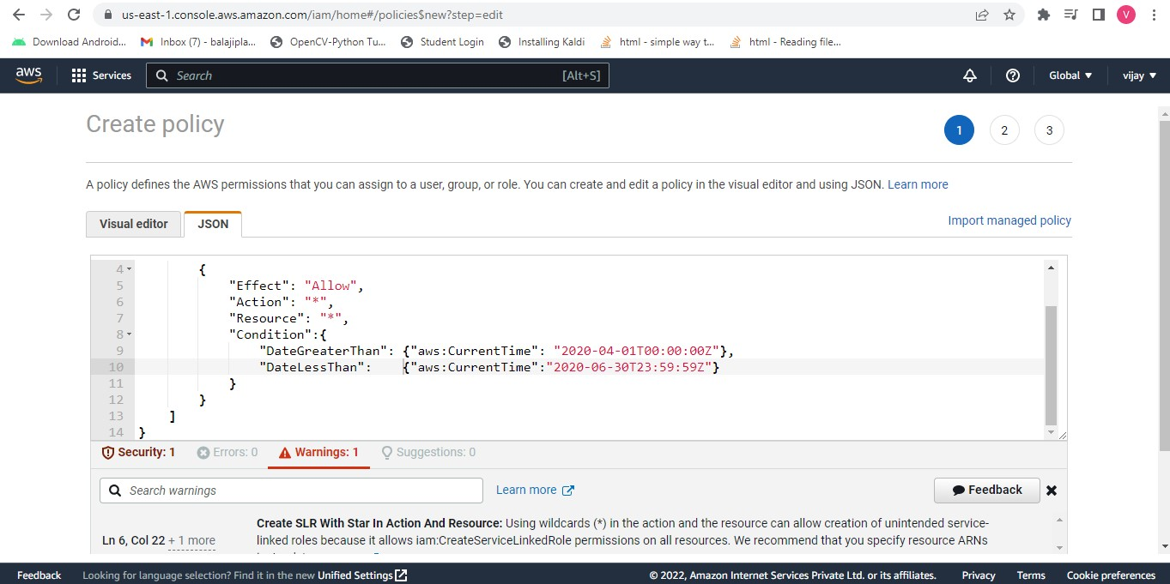

Assignment 3 :- Prepare 15 authentic MCQ questions related to IAM.

1. When you first create an Amazon Web Services (AWS) account, you begin with a single sign-in identity that has complete access to all AWS services and resources in the account. This identity is called: **Root User.**
2. **IAM USER Group** is the collection of IAM users.
3. IAM User can be assigned upto **10** groups
4. **IAM group** can be used to specify the permission for the collection of users
5. **IAM** control access to services and resources under specific conditions.
6. **IAM** roles provide a way to access AWS by relying on temporary security credentials.
7. **Role Based Access Control** is used to give limited access to the user according to their job functions.
8. Is creating an IAM user is chargeable In AWS? **No**
9. **Inline policy** used we need to have a strict one-one policy and identity to which it is applied to.
10. **Inline policy** used in order to grant administrative permissions to ensure they are not attached to other roles
11. **Resource-based** policies are the permission policies that are attached to the resources.
12. **ABAC** is an authorization strategy that defines permissions based on attributes.
13. In AWS, these attributes are called **tags.**
14. **IAM policy simulator** evaluates policies you choose and determines the effective permissions for each of the actions you specify.
15. User, Groups and roles are **identity** in IAM

**Assignment 4 :- Launch your linux instance in IAM and update your machine.**

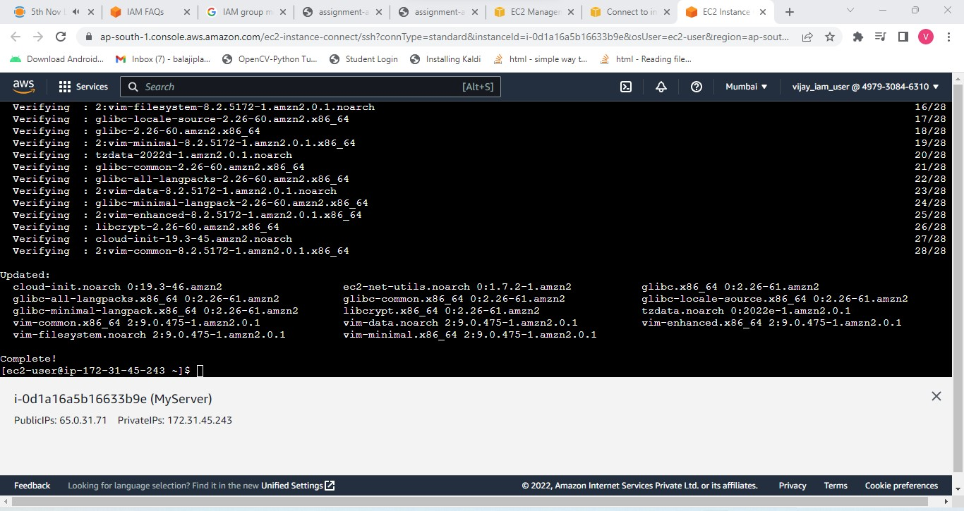

Created a IAM user given admin access policy and launched the EC2 instance using IAM credentials as IAM user and updated